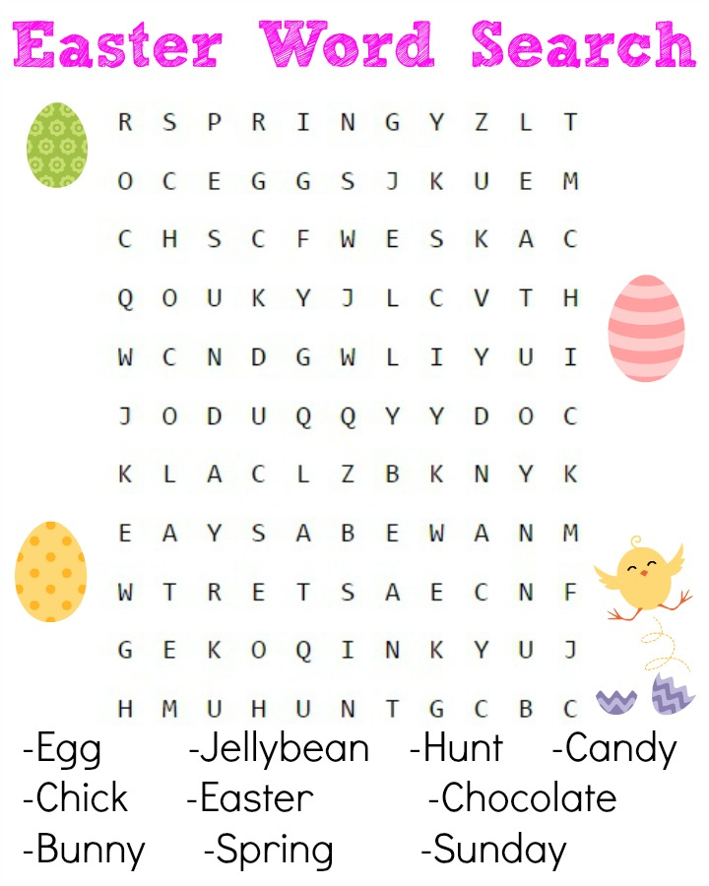

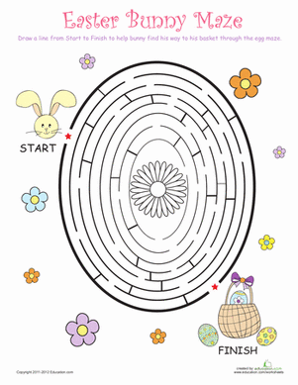

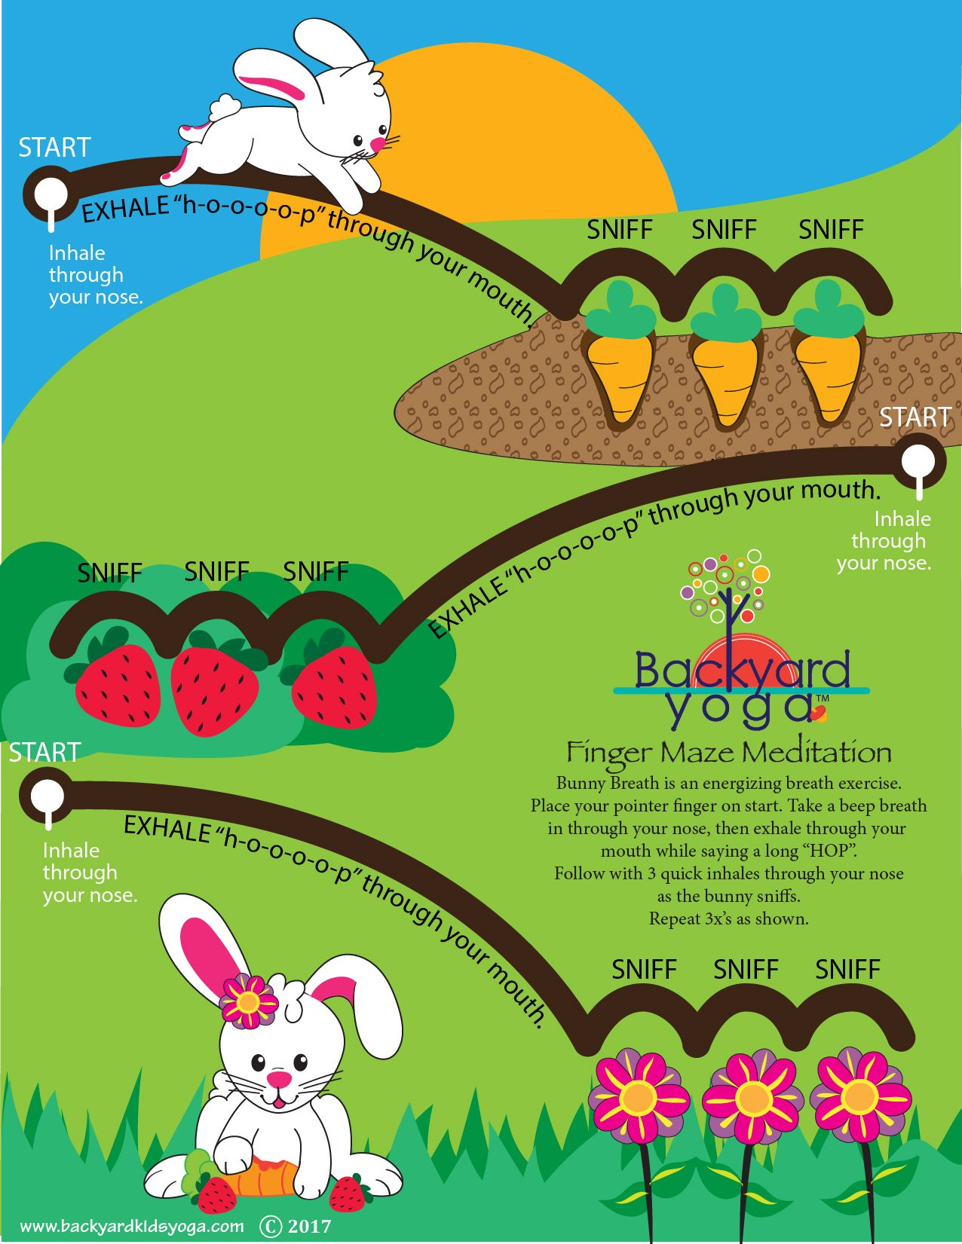

- Make Hot Cross Buns
https://www.bbcgoodfood.com/recipes/easy-hot-cross-buns (Recipe)

- Colouring pages (Download from twinkl)

- Cosmic Kids Yoga Disco – Bunny Bounce
https://www.youtube.com/watch?v=9gV85rd3yTc

- Cosmic Kids Yoga – Peter Cottontail and the Tickly Monkeys (Easter Themed)
https://www.youtube.com/watch?v=uNrIB6O_Abo

- “I’m Somebunny Special” activity


