Fun in the Kitchen
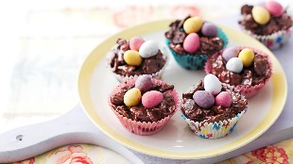
Easter Egg Nests
https://www.bbc.co.uk/food/recipes/eastereggnests_93841

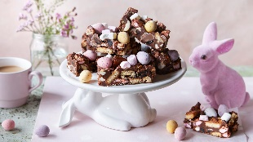
Easter Rocky Road (No Baking Required)
https://www.bbc.co.uk/food/recipes/easter_rocky_road_82814

Easter Biscuits
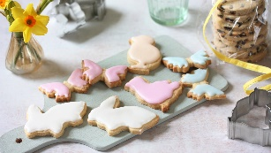
https://www.bbc.co.uk/food/recipes/easter_biscuits_37686

Easter Egg Blondies
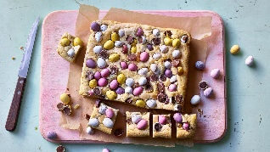
https://www.bbc.co.uk/food/recipes/easter_egg_blondies_39122

Easter Fruit Cupcakes (alternative to Hot Cross Buns)
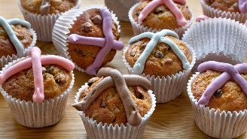
https://www.bbc.co.uk/food/recipes/easter_fruit_cupcakes_75736

Vegan vanilla cupcakes
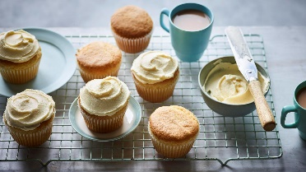
https://www.bbc.co.uk/food/recipes/vegan_vanilla_cupcakes_62123

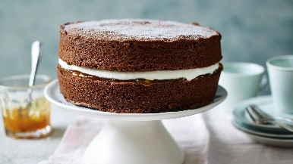

Mary Berry’s Chocolate Cake
https://www.bbc.co.uk/food/recipes/definitivechocolatec_72226
You could add a chocolate frosting or icing and decorate with mini eggs for a lovely Cake for Easter,

