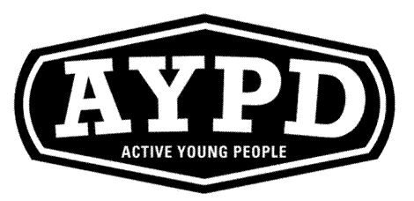
The FUNS for everyone programme.
Challenge 2
Seated Static balance, is this week’s challenge.

FUNS for everyone is a programme contains 12 challenges. The programme consists of a variety of colour coded cards, each structured around a staged series of challenges that introduce, build and develop the core fundamental movement skills- balance, coordination and agility. First funs is specifically for early years and key stage 1 and therefore covers the first 3 colours in the programme – yellow, green and red.
We would like you to use the cards as home challenges.
Start with the Yellow card once you have completed the yellow card you can progress onto green and then red.

Remember everyone is different and some people will find these challenges easy and some will find them hard, don’t give up, keeping practicing and you will get it. Remember practice make perfect!
Why not try and get all of your family taking part, but most importantly have fun!



